PAYMENT REQUEST

INV DATE : 10/16/2023

TO,
Nalanda Public School
Mulund, Mumbai

S.NO | DESCRIPTION – Contribution towards Virasat series concerts and workshops by | Date of event | TOTAL AMOUNT
1 | Rupak Kulkarni | Oct 5th, 2023 | Rs 25,000
2 | Vidyadhar Vyas | Oct 4th, 2023 | Rs 25,000
3 | Vidyadhar Vyas –3 workshop sessions | Oct 4-6th, 2023 | Rs 15,000
4 | Darshana Jhaveri – 1 concert | Oct 6th, 2023 | Rs 25,000
5 | Darshana Jhaveri –3 workshop sessions | Oct 4-6th, 2023 | Rs 15,000
6 | Ambika Yog Kutir – 6 workshop sessions | Oct 4-6th, 2023 | Rs 18,000
7 | Babu Lal – Tie and Dye – 3 workshop | Oct 4-6th, 2023 | Rs 9000
8 | Manimala Chitrakar – 3 workshop sessions | Oct 4-6th, 2023 | Rs 9000
9 | Dhanalakota Padma – 3 workshop sessions | Oct 4-6th, 2023 | Rs 9000
10 | Prakash Joshi – 3 workshop sessions | Oct 4-6th, 2023 | Rs 12000
11 | Ram K Chippa – 3 workshop sessions | Oct 4-6th, 2023 | Rs 12000

Total (in Rupees): Rs 1,74,000

Amount in words: Rupees One Lakh Seventy Four Thousand Only

Kindly deposit the contribution payment amount in SPIC MACAY Mumbai Chapter Bank Account.
The bank account details are as follows:

Bank Name – SBI
Branch – IIT Powai
Account No – 34943147257
IFSC Code – SBIN0001109

Regards,

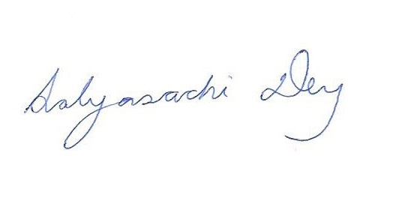
(Sabyasachi Dey)
National Secretary,
SPIC MACAY

